Report by: 1409046  
Role: Level Design & Artist liaison

Game Version: Latest – with Menus  
Date Reported: 25/04/2016

QA Status: Passed

Severity: Minor

Priority: Moderate

Test Introduction:

The purpose of this test was to check the player could successfully go up a ramps to get to a certain pick up and onto the top layer of the map. To test this, I drove the ship to the ramps position and drove forward from there.

Expected outcome:

I expect the ship to drive up the ramp without slowing or wavering side to side

Actual outcome:

When the ship started to go up the ramp it was losing speed and in some cases the ship was being destroyed as its velocity was at 0, which is what initiates the death state from our scripts. The ship does stay in place as it goes up the ramp.

Screenshot of the bug:

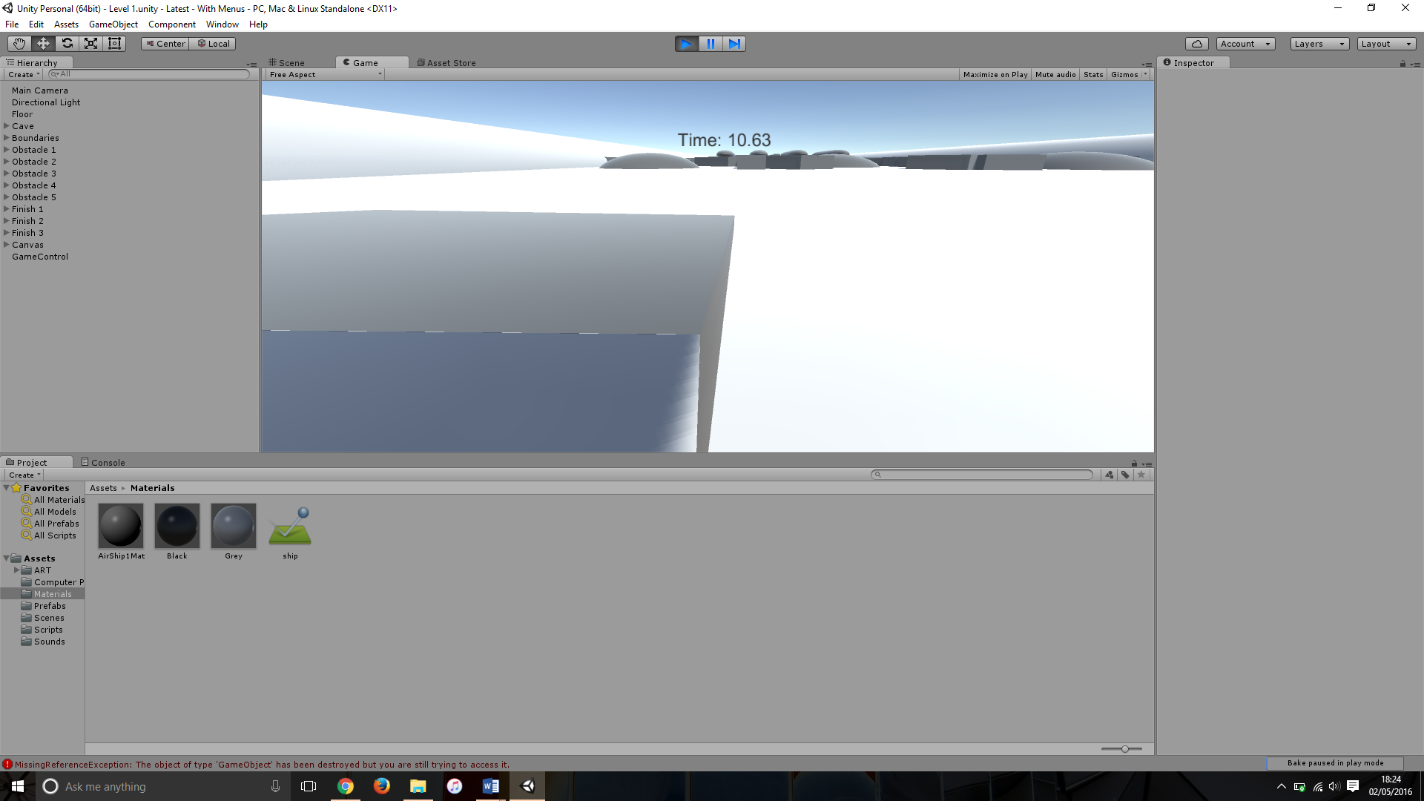

This is showing the ship destroyed as it has no speed to get down the ramp

Potential cause:

One cause for this problem could be that the object used for the ramp has the ‘obstacle’ tag, this means that the ship will be slowing down because when the player ‘grinds’ against obstacles it will take speed away from the ship.

Suggested Fix:

To fix this bug I removed the obstacle tag from the ramps and top layer plane and also added the ‘ship’ material to the models as this means it would have no effect on speed.